**How to Setup & Run this Project**

❖ **Install NodeJs ( Ignore If Already Installed)**

1.Visit the official Node.js website i.e) <https://nodejs.org/en/download/>2.Download the Node.js installer

3.Run the installer.

4.Follow the prompts in the installer.

# —First Run Backend then Frontend & Admin—

❖ **Steps To Setup Backend Of The Project**

1. Open Project Folder In VS Code
2. Open Integrated Terminal

- Right Click on Sidebar > Select “Open In Integrated Terminal”

3.Type “npm install” and press Enter and Wait for

Installation to be completed (requires Internet) 4.Setup The MongoDB

**a.**Open this link - [LINK](https://www.mongodb.com/cloud/atlas/register)

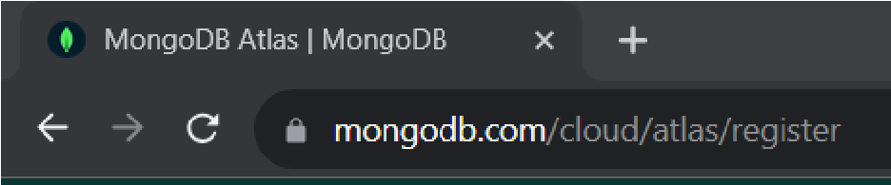

**b.**After that Sign Up on the website.

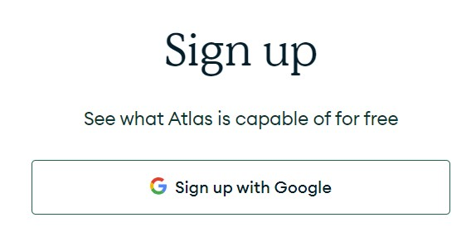

**c.**Click on New Project Option

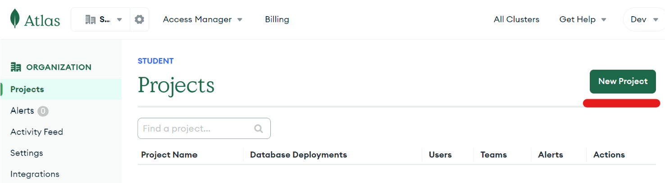

**d.**After Creating Project go to Database Section & Build a database

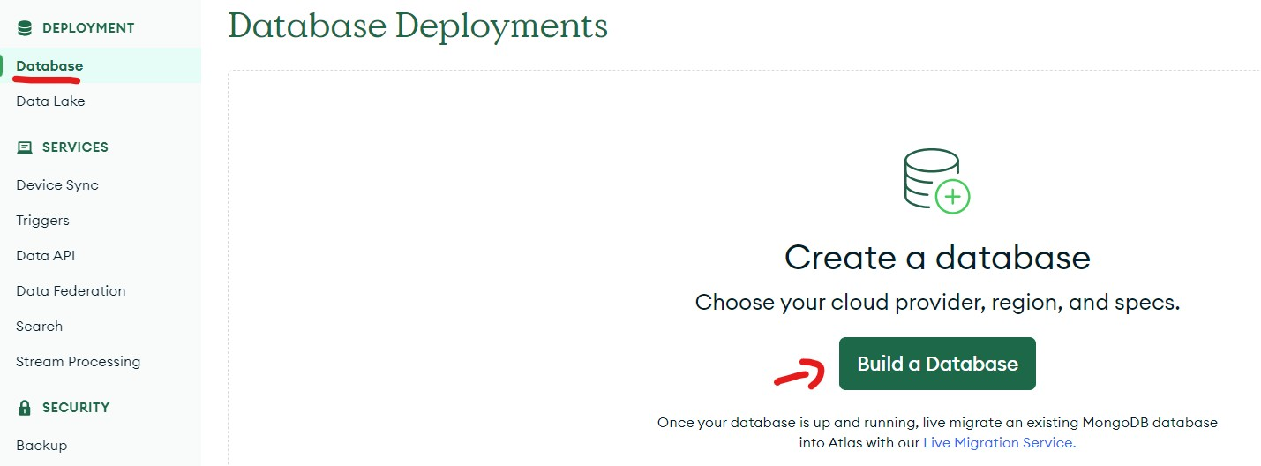

**e.**Select M0 & Your Region & Create Database

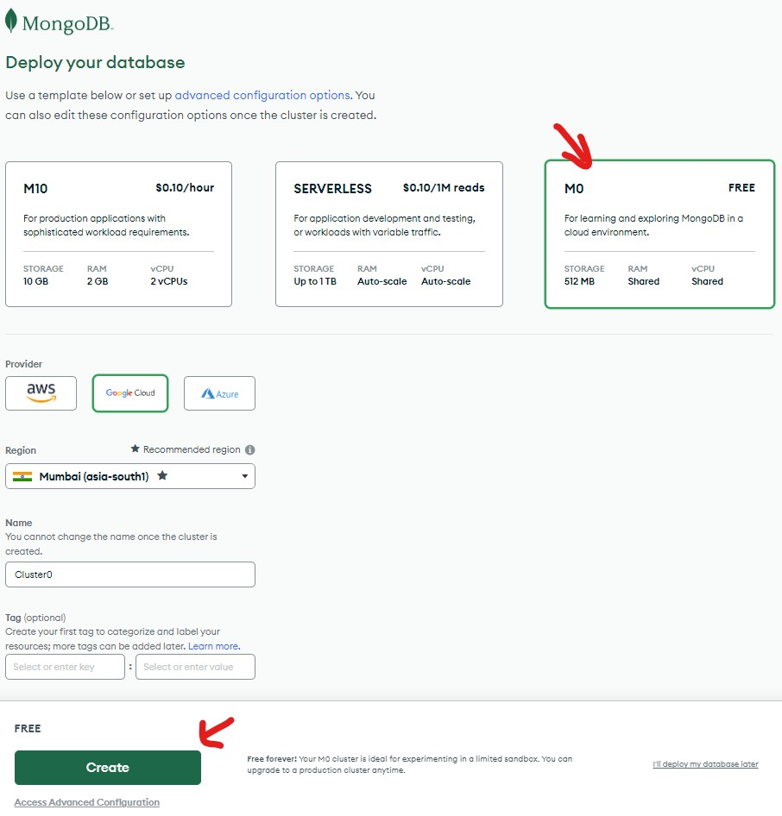

**f.**Setup Username & Password & Create User

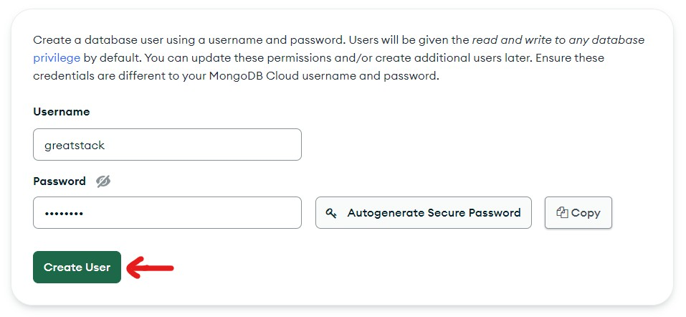

**g.**Add IP 0.0.0.0 & Click on Add Entry

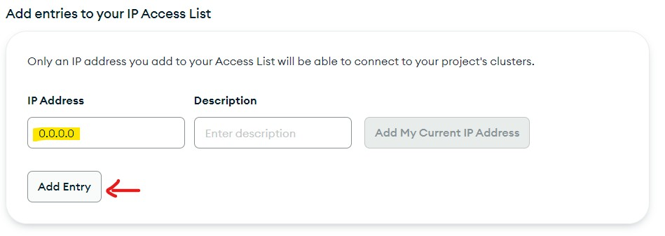

**h.**Now Click on Finish & Close

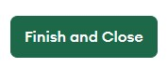

**i.**Now Click on Connect

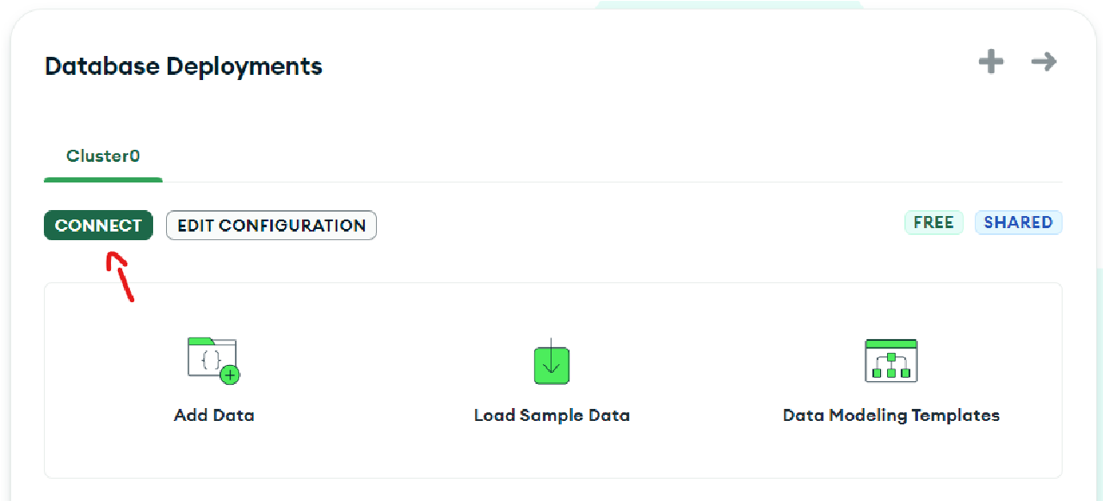

**j.**Now Select Compass Option

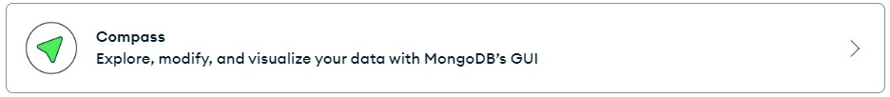

**k.**And Copy the Connection String

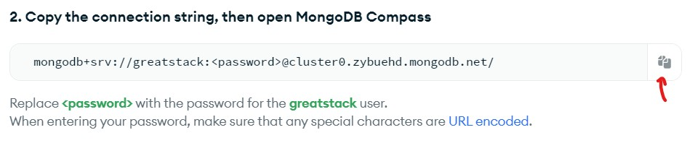

**l.**And Paste It in index.js replace <password> with

password you set previously in 4.F & save changes

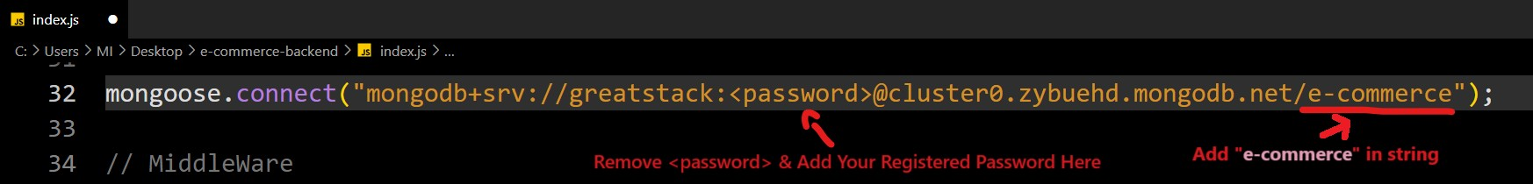

5.To Run Project use node .\index.js in Integrated Terminal



❖ **Steps To Run Frontend & Admin Panel Of The Project**

1. Open Project Folder In VS Code
2. Open Integrated Terminal

○ Right Click on Sidebar > Select “Open In Integrated Terminal”

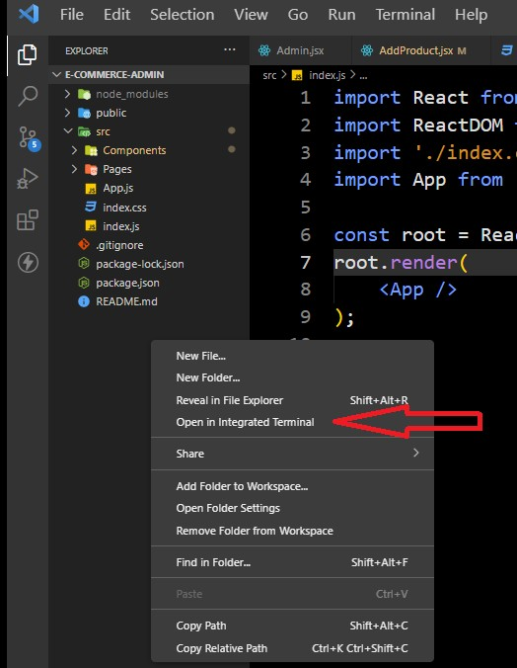

3.Type “npm install” and press Enter and Wait for

Installation to be completed (requires Internet)

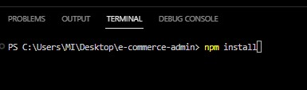

4.After Installation You will See ‘node_modules’ Folder in the Sidebar

5.After that type “npm start” in terminal

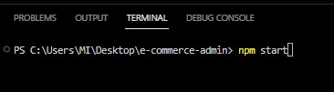

6.Now Your Project Will Start In Your Default Web Browser